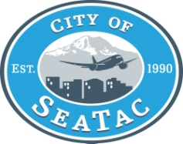

Information Notice

**Free Tax Help from the United Way**

The Angle Lake Family Resource Center and United Way of King County's Free Tax Campaign are partnering to offer free tax services to SeaTac residents. From now until April 15, anyone making under $52,000 a year can drop in and have their taxes prepared for them in their own language.

In addition to tax help, benefits volunteers will also be on site to help with health care enrollment, credit pulls, and money for college or food. This service is always free and provided by local volunteers. Volunteers receive excellent training and support throughout the year from the United Way team.

Additional volunteers are especially needed in SeaTac! To learn more about this service, or to join the team as a tax preparer or benefits volunteer, visit [www.uwkc.org/taxhelp](http://www.uwkc.org/taxhelp).

Posted 3.4.14

Lesa Ellis, Executive Assistant