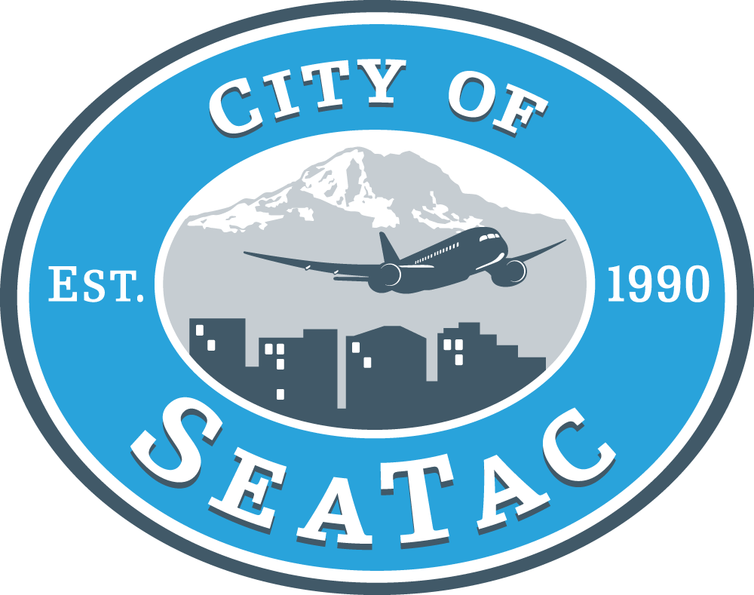 | Office of Human Services  4800 South 188th Street  SeaTac, WA 98188  Colleen Brandt-Schluter, cbschluter@ci.seatac.wa.us  (206) 973-4815

Years Covered By This Application Process
Human Services funding (from the City General Fund) is allocated on a biennial basis. For public services, this means that programs funded for 2013, will be renewed for 2014, contingent on adequate funding availability and program performance.

Application Submittal Information
All applications are due on Thursday, April 26, 2012, by 4:00 p.m. and must be submitted online at http://share1app.culturegrants.org/. Late applications will not be accepted. Please check this website frequently for changes or updates. Applicants are instructed to not wait until the final days or hours to submit applications. Applications should be submitted as soon as possible.

Approximate Funding Available
There is approximately $350,000 available per year for Human Services programs. Currently funded agencies are not guaranteed ongoing funding but will be evaluated based on the application submitted. It is critical that all applications are complete and provide accurate descriptions of the programs being proposed for funding. All agencies, even those that have received previous funding, should assume that the Committee is not familiar with the services and programs provided. The agency bears the burden of demonstrating the value and strength of the program within the application.

Application Assistance
If you need assistance or have questions about the application content, the process, or the city’s priorities, you are strongly encouraged to contact Colleen Brandt-Schluter at (206) 973-4815, cbschluter@ci.seatac.wa.us .

Application Review Process
The City of SeaTac Human Services Advisory Committee, a group of citizens appointed by the Mayor and approved by Council to guide human services policies for the city, will review applications for funding. The Committee will make funding recommendations on the use of General Fund Human Service allocations to the Council in September/October 2012. Funds will be available in January 2013.

Additional Information Required
In addition to scoring the on-line application, the SeaTac Human Services Advisory Committee has identified six Results for SeaTac (conditions of well-being for the city’s residents) and strategies to improve those Results. Applications will be scored on how well they address the Results and Strategies identified by the Committee. Fund allocation will be based on what strategies agencies use and how well they can address the Results using those strategies.

Applicants to the City of SeaTac must UPLOAD no more than one written page that identifies the Results their programs/services address, the strategies they will use to address those Results, and how the agency will implement those strategies. The Results/Strategies are listed below in the section titled, “Funding Criteria”, can be downloaded at http://www.ci.seatac.wa.us/index.aspx?page=107, and will also be handed out at the application workshops on 3/7/12 (Kirkland) and 3/15/12 (Renton). Please make sure to access the webpage to understand the full requirements for this additional page. Upload this document (in addition to all other required supporting documents) with your application.

Funding Criteria
Results and Strategies for the City of SeaTac are as follows:

Result #1: Residents are healthy, physically and mentally
Strategies to improve:
- Offer mental, physical and dental health services in the community
- Provide innovative services that are sensitive and responsive to resident’s needs
- Offer healthy food strategies that increase food security

Result #2: Residents are educated and have necessary life skills
Strategies to improve:
- Provide educational programs and incentives for parents and youth of all ages
- Provide life skills training (i.e. financial literacy, ESL, parenting, nutrition, system navigation, etc.)

Result #3: Residents are employed in living-wage jobs
Strategies to improve:
- Improve transportation access and usage
- Provide entrepreneurial and micro-lending opportunities
- Provide employment and skill building opportunities
- Provide access to adequate, high-quality, affordable childcare

Result #4: Residents are safe from all types of violence
Strategies to improve:
- Provide crisis services that are accessible and responsive
- Provide education and advocacy to residents on how to stay safe
- Provide safe places for residents

Result #5: Residents have adequate secure housing
Strategies to improve:
- Provide emergency assistance to include case management, counseling, tenant rights education and other resources
- Offer supportive housing services, including case management and coordination with other agencies

Result #6: Residents embrace diversity
Strategies to improve:
- Create opportunities and activities to build a sense of community
- Increase community participation and decision-making to build a diverse voice
- Increase partnerships with community based organizations and schools
- Improve coordination and communication efforts to increase effectiveness and efficiency and improve community relationships

Technical Assistance with share1App
If you are experiencing technical difficulties or have questions about the technical side of share1app, please email share1appquestions@gmail.com. Responses will be made up to 24 hours after your initial inquiry. In addition, technical assistance will only be available Monday through Friday, from 8 a.m. to 5 p.m. Be sure to include your name, phone number, and the agency and program you represent.

