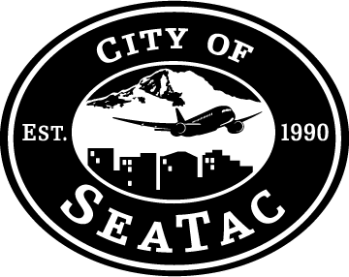

Transportation and Public Works

Committee Meeting Agenda – Revised

September 27, 2011

2:30 PM

Airport Conference Room 345

Ralph Shape, Chair

Mia Gregerson

Rick Forschler

Staff Coordinator: Tom Gut, Public Works Director

1. Ordinance authorizing City Manager to execute Franchise Agreement with Comcast – *Mark Johnsen (5 minutes)*
2. Update on SR 509 Completion Project – *Tom Gut (30 minutes)*
3. Approval to pursue Department of Ecology Stormwater Quality Grant opportunity for Military Road South Project – *Tom Gut (5 minutes)*