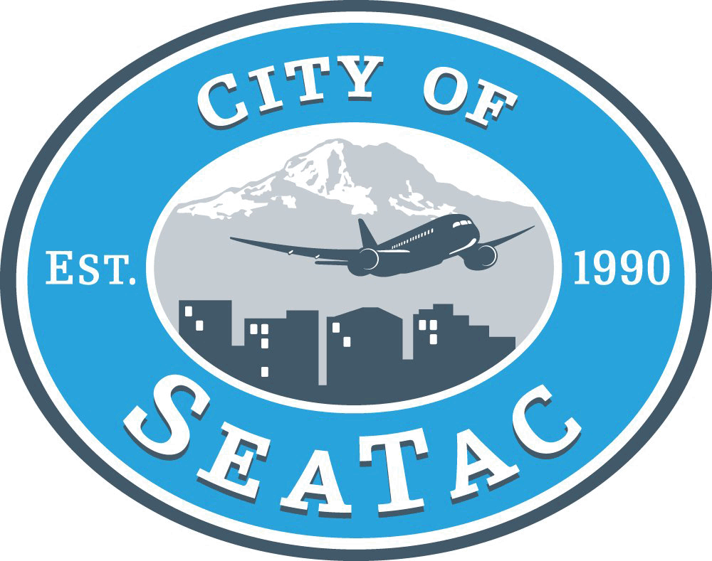
Adopt-A-Street
Volunteer Activity Report

Please attach Volunteer Activity Roster to this Report.

Name: ____________________________ Organization: ________________________

Phone Number: ________________________ Email: ___________________________

Location: _______________________________________________________________

Date of Activity: _________________ Start Time: _________ End Time: __________

How many total volunteers participated? _____________________

How many bags of trash were collected? ______________________________________

Please describe and give approximate location of any collected bags and if there were any large, heavy or bulky items that the City needs to collect?
_____________________________________________________________________________________________________________________________________________________________________________________________________________________

Were there any hazardous, toxic, or otherwise unacceptable items (needles, syringes, broken glass, chemicals, etc.) that were marked with flags and need to be collected by the City? Please describe and give approximate location.
_____________________________________________________________________________________________________________________________________________________________________________________________________________________

Were there any unusual incidents or injuries during the clean up?
_____________________________________________________________________________________________________________________________________________________________________________________________________________________

To activate insurance, please return this form and Volunteer Activity Roster within
3 days of completion of cleanup:

Scan & Email:  - mgiem@seatacwa.gov | or Mail:  City of SeaTac  4800 South 188th St  SeaTac, WA 988188  Attn: Mason Giem/Adopt-A-Street Program

