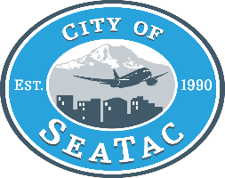
Community Services Advisory Committee
Agenda

November 8, 2021
5:30 PM
Virtual

The Community Services Advisory Committee serves the City Council by advising on human services issues including:
- Community service needs
- Human services priorities
- Plans and policies
- Funding requests
- Annual funding plans
- Collaborative & regional planning initiatives
- Service trends & updates

Members: Judith Williams, Charrise Oden, Dennis Cooper, Andy Sevao, Christine Bertie

Staff Coordinator: Kim Cooper, Human Services Coordinator

A quorum of the Council may be present.

Due to the current COVID-19 public health emergency, and social distancing protocols, pursuant to the Governor’s and public health officials’ orders, this meeting will be conducted virtually. The public may call in to the conference line to listen to the meeting. The number is 206.973.4555. While you will be able to hear the meeting; you will not be able to participate in the meeting. Please note that if you are unable to mute your phone, everyone else on the call-in line will be able to hear you, so please refrain from speaking. City Hall is closed so no one will be able to physically attend this meeting.

ITEM | TOPIC | PROCESS | WHO | TIME
1 | Call to Order |  | Chair | 5 minutes  5:30-5:35pm
2 | Approval of the 10/11/2021 Minutes | Approval | Members | 5 minutes  5:35-5:40pm
3 | Presentation: REACH | Presentation | Pattie Holt-Program Manager | 25 minutes  5:40-6:05pm
4 | Human Services Updates | Information only | Kim Cooper | 20 minutes  6:05-6:25pm
5 | Next meeting- December 13, 2021 |  |  | 5 minutes  6:25-6:30
6 | Adjourn |  |  | 5 minutes  6:30-6:35

