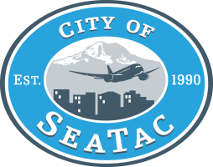**MEMORANDUM**

To: Transportation and Public Works Committee

Through: William Appleton, Public Works Director

From: William Appleton

Date: 1/8/18

Subject: State Route 509 Completion Project – Madrona/ Mansion Hills Elements

**Purpose:**

Construction of both the State Route 509 Completion Project as well as the Sound Transit Light Rail Extension Project (ST3) necessitate that changes be made to the roadway network within the Madrona/ Mansion Hills Neighborhoods. In light of recent concerns expressed by the owners of Sandpiper Apartments, the approved mitigation project for the Madrona Hills neighborhood will be discussed in greater detail to both reaffirm agency commitments and answer any questions the Committee may have.

**Background:**

As mitigation for the future SR509 project, WSDOT has agreed to construct and pay for all improvements as outlined in the attached MOU dated June 27, 2017, which provides for the connection between S 208th St/S 204th St/34th Ave S and a new connection with International Blvd at S 206th St (see attached Exhibit – S 206th St/34th Ave S Option). The mitigation measures agreed to were the result of numerous meetings/discussions between the WSDOT SR509 team, City staff, and other stakeholders in the area and determined to be the best suited to meeting the needs of transportation, life safety and pedestrian needs of our community moving forward. The approved mitigation does not come without impacts to the community, including the need to acquire additional ROW to facilitate the construction of new roadway connections and needed changes to existing roadway alignments. WSDOT, together with the City has conducted public outreach throughout this process to provide the opportunity for our residents and property owners to comment and stay informed.

**Attachments:**

* Exhibit – S 206th St/34th Ave S
* Memorandum of Understanding between City of SeaTac and WSDOT related to the Madrona/ Mansion Hill mitigation dated June 27, 2017________