Traffic Calming 101
“In almost all U.S. cities, the bulk of the right-of-way is given to the roadway for vehicles, the least to the sidewalk for pedestrians… just suppose that Americans were to extend their walking radius by only a few hundred feet. The result could be an emancipation… –William H. Whyte (CITY: Rediscovering the Center)
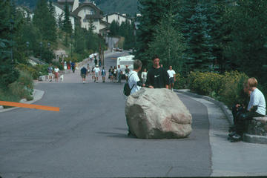
Developed in Europe, traffic calming (a direct translation of the German “vekehrsberuhigung”) is a system of design and management strategies that aim to balance traffic on streets with other uses. It is founded on the idea that streets should help create and preserve a sense of place, that their purpose is for people to walk, stroll, look, gaze, meet, play, shop and even work alongside cars – but not dominated by them.

The tools of traffic calming take a different approach from treating the street only as a conduit for vehicles passing through at the greatest possible speed. They include techniques designed to lessen the impact of motor vehicle traffic by slowing it down, or literally “calming” it. This helps build human-scale places and an environment friendly to people on foot.

Besides its power to improve the livability of a place, the beauty of traffic calming is that it can be applied inexpensively and flexibly. The strategies outlined below in The Traffic Calming Toolbox can be employed by painting lines, colors and patterns; using planters, bollards and other removable barriers; eliminating or adding parking; or installing sidewalk extensions or similar structures with temporary materials. All provide an opportunity to test devices, combinations and locations, fine-tuning the approach according to results. Traffic calming, along with other small-scale improvements, can enhance a place immediately, while being tested and refined to meet long-term needs. When funds are available, the right combination of devices can be transformed into permanent improvements and extended over a broader area. Regardless of what traffic-calming action is undertaken, the benefit to a community is greater when the technical improvements are strengthened by visual enhancements like trees, flowers and other amenities.
The Traffic Calming Toolbox
- Diagonal Parking
- Changing One-Way Streets to Two-Way
- Widening Sidewalks/Narrowing Streets and Traffic Lanes
- Bulbs – Chokers – Neckdowns
- Chicanes
- Roundabouts
- Traffic Circles
- Raised Medians
- Tight Corner Curbs
- Diverters
- Road Humps, Speed Tables, and Cushions
- Rumble Strips and Other Surface Treatments

BEFORE TRAFFIC CALMING: MAJOR CONSIDERATIONS

TRANSIT AND TRAFFIC CALMING

LIABILITIES

THE TRAFFIC CALMING TOOLBOX

1. DIAGONAL PARKING
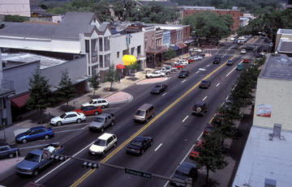
Cars park diagonally, jutting out from the curb, rather than parallel to it. The benefits:
- Simple and inexpensive
- Changes both the perception and the function of a street
- Shortens the “peering distance” for people crossing the street
- Drivers pulling out must be alert to approaching traffic
- Oncoming drivers must be alert to the cars pulling out
- All of this added driver awareness creates more awareness of pedestrians
- Can add up to 40% more parking space than parallel parking

2. CHANGING ONE-WAY STREETS TO TWO-WAY
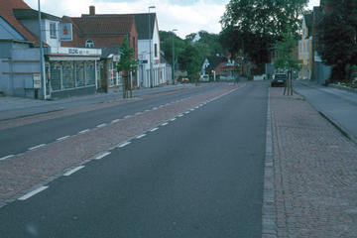
Single or double traffic lanes, either face-to-face or with a median, sometimes flanked by parking. The benefits:
- Less driving, less confusion, and better traffic access
- Eliminates the need to drive blocks and blocks out of the way
- No need to make extra turns to get to nearby destinations
- Drivers can get directly to their destination
- Increases commercial traffic and business
- Decreases the speed of traffic

3. WIDENING SIDEWALKS/NARROWING STREETS AND TRAFFIC LANES
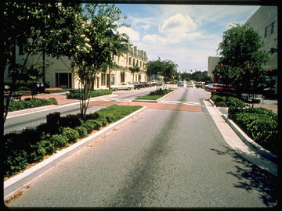
These techniques provide a flexible way to take back space from the street for non-motor-vehicle uses. Traditional traffic engineering calls for 12- to 13-foot lanes, citing “traffic safety” standards – but newer evidence shows that lanes as narrow as nine feet can still be safe for driving.
- Narrowing lanes and to widen sidewalks eases crossing for pedestrians and gives them more space to walk.
- Lanes can also be removed from serving traffic and designated for busses, trolleys, or other types of transit.
- Traffic lanes can be transformed into bicycle lanes.
- All street lanes can be narrowed together to create more room for non-auto uses.
- Vertical elements like trees or bollards further reduce the “optical width” of a narrowed street, thereby discouraging speeding.

4. BULBS – CHOKERS – NECKDOWNS
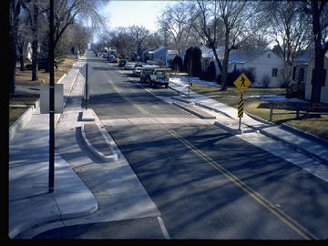
Interchangeable terms for sidewalk extensions in selected areas – such as at intersections or at mid-block – as opposed to a full sidewalk widening. The benefits:
- Provide a haven for pedestrians waiting to cross the street
- Shorten the crossing distance
- Define parking bays
- Deflect through traffic at a corner
- Function as entry points
- Provide space for amenities and enhancements (e.g. kiosks, trees, lighting)

5. CHICANES

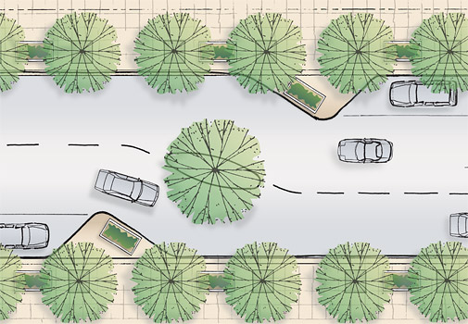

Sidewalk extensions that jog from one side of a street to the other to replicate such a circuitous route. The benefits:
- Narrow, curving roads encourage motorists to drive more slowly and carefully
- An undulating path interrupts any clear view ahead and compels drivers to slow down
- Chicanes can be formed using sculpture, plantings and parking to enhance the appearance and function of a street
- Diagonal parking and parallel parking can be alternated to create a chicane effect.
- Chicanes are best used on narrow roads, to prevents cars from swinging out to maintain their speed around the bends.

6. ROUNDABOUTS
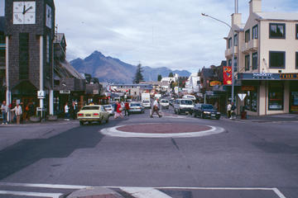
Large, raised, circular islands at the middle of major intersections, around which all oncoming vehicles must travel until reaching their destination street, where they then turn off. The benefits:
- Create a “calmed,” steady flow of traffic
- Reduction in conflict points, which can lead to fewer accidents
- Traffic signals are not customarily required (although traffic control signs are prominent)
- Streets narrow as they approach the roundabout, and crosswalks are installed on these approaches – thereby slowing oncoming vehicles and giving pedestrians a safe, obvious opportunity to cross
- Enhanced with fountains, sculpture or attractive landscaping, the island can serve as a striking gateway
- A sloping ramp around the perimeter of the raised island allows buses, trucks and other large vehicles to maneuver the continuous curve while still maintaining a lowered speed.

7. TRAFFIC CIRCLES
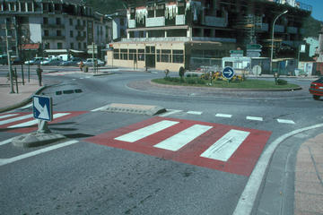
Essentially “mini-roundabouts” designed for small intersections, often used to slow traffic from a wide street into a smaller local street. Traffic circles:
- Help to slow down traffic in neighborhoods and remind drivers that they must proceed carefully
- Help to sustain lowered vehicle speeds when they’re used in a series
- Provide an opportunity for community activity in residential areas, where citizens can create plantings or add other enhancements

8. RAISED MEDIANS
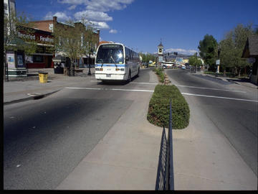
Elevated islands parallel to traffic lanes down the middle of the street, as on a boulevard. The benefits:
- Curtail vehicle space
- Provide a safe in-between refuge for pedestrians as they make their way across the street, split up a lengthy curb-to-curb distance (especially helpful for people who cannot move quickly)
- Provide ideal locations for trees, flowers, sculpture and other amenities

9. TIGHT CORNER CURBS

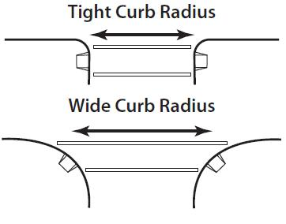

The longer the radius of a curve, the faster a vehicle can move around that curve – as many pedestrian witness when, in crossing at an intersection, they are confronted by a car whizzing around the corner seemingly out of nowhere. Reducing a corner radius to somewhere between one and twenty feet can:
- Inhibit the speed of turning vehicles
- Give pedestrians a better chance to see and be seen by approaching traffic
- Add sidewalk space, thereby shortening the distance to the other side of the street

10. DIVERTERS
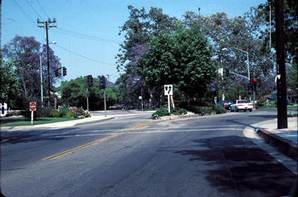
These physical barriers redirect traffic heading for a certain street onto a different course, reducing vehicle overload on vulnerable (usually residential) streets overrun by through traffic looking for shortcuts.
- Diagonal Diverters traverse an entire intersection, actually creating two unconnected streets that each turn sharply away from one another.
- Semi-Diverters restrict traffic in one direction to prevent entrance to a street, while permitting traffic to pass through in the other direction.
- Although they effectively reduce traffic volume, diverters must be part of a comprehensive improvement scheme or else they can end up simply displacing congestion.

11. ROAD HUMPS, SPEED TABLES, AND CUSHIONS
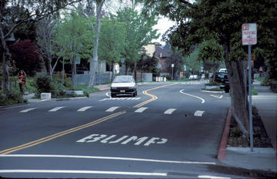
These devices reduce speed by introducing modest up-and-down changes in the level of the street, thereby requiring drivers to decelerate.
- Road humps (or “speed humps”) are rounded mounds, approximately three inches high and 10 to 12 feet long. They effectively slow down traffic to 15-20 mph without making drivers uncomfortable. For optimum speed reduction, road humps need to be placed at frequent, designated intervals based on the street’s dimensions, to minimize the tendency to accelerate between them. (Humps are not to be confused with the speed bumps, which are usually at least 5-6″ high and less than three feet long.)
- Speed tables are road humps that are flat on top and sometimes slightly longer. They are the same width as the street and rise to meet the grade of the sidewalk, providing safe and comfortable crossings for walkers and wheelchairs (and greater access for snow clearance than road humps). One benefit of speed tables is that people cross at the point where drivers decrease speed.
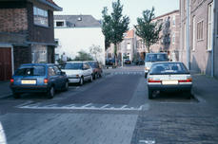
- Cushions cover only part of the width of the street to allow passage for emergency vehicles, buses or other large vehicles, and bicycles; they are usually placed at varying intervals to respond to the need to channel the wheels of larger vehicles, while still providing hurdles wide enough to slow standard-sized vehicles.
- It is important to highlight road humps, speed tables and cushions with clear markings to alert approaching drivers. This can be accomplished by: painting words and symbols directly on the street; changing the texture of the street surface; or using signage (the word “Bump” instead of “Hump” is a standard approach thought to effectively put drivers on the alert).

12. RUMBLE STRIPS AND OTHER SURFACE TREATMENTS
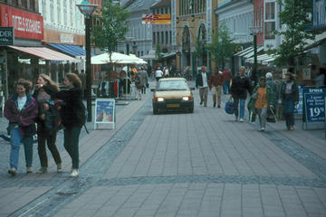
- The rumble strip provides visual and aural cues to alert drivers to areas that require special care (shopping centers, freeways undergoing construction work, schools, entrances to residential neighborhoods). Materials like granite and concrete are roughened by being broken into raised lines or patterns, and placed in strips across roadways, usually in a series. Drivers can lessen the vibration and the abrasive sound they create by slowing down.
- Changes in pavement color and texture (such as bricks or Belgian blocks), used in interesting and visually attractive ways, can also have the effect of rumble strips. These paving treatments also: delineate and create awareness of a pedestrian crosswalk or haven; make a street appear narrower than it is to deter speeding; define a street from a sidewalk or a parking lane.

BEFORE TRAFFIC CALMING: MAJOR CONSIDERATIONS
The “starter set” of traffic-calming tools outlined above can be effective in a variety of ways. However, each tool has its own specific applications, and not every one fits every single circumstance. Some tools are more effective if used in combination with each other, or with alternative transportation approaches like bicycles, buses or light rail. The right use hinges on existing conditions along a street and the desired outcomes. The following is a sampler of issues that need to be considered when making
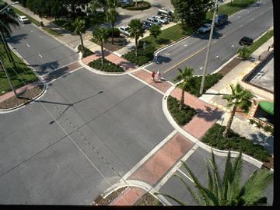
traffic calming choices.
- Do emergency and service vehicles use the area? Do school buses?
- Is there a problem with through traffic?
- What are the surrounding uses? Residential? Commercial? Retail? Cultural? Entertainment? Civic? Educational? Other?
- Who are the users? Are there many elderly or disabled people or children?
- What kinds of activities are going on in the vicinity or are planned to go on?
- Are there plans for improving the area? If so, how?
- What kinds of streets are being looked at? What is the ideal speed desired?
- Is transit service available? If so, where and what kind?
- Where is drainage needed?

TRANSIT AND TRAFFIC CALMING
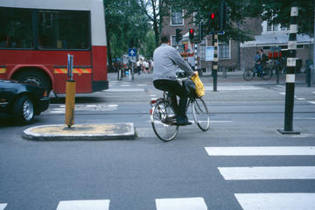
Transit can be an efficient, more economical and less polluting alternative to the automobile – but transit alone doesn’t necessarily make a place more livable. People still need to cross streets safely to reach a train station, bus stop, or other transit hub. And they need a pleasant and direct walking route along the way. This is where traffic calming comes in.
Traffic calming measures can make the trip to the transit station more walkable and convenient, while providing space for amenities to make the trip more pleasant. Although traffic calming and transit seem to be natural partners, sometimes their goals can conflict. When a traffic-calming strategy performs its job well, it may interfere with the efficient movement of a transit vehicle, or even its comfort, as when speed humps create a bumpy ride on buses. Certain strategies can maintain the benefits of traffic calming while allowing transit to function effectively:
Cushions enable buses to pass smoothly over an area, yet still slow smaller vehicles. Bus “bumpouts” or “nubs” allow buses to pick up passengers without having to move out of the traffic lane. They extend across a parking lane to meet the traffic lane (and the bus that is in it), giving passengers a safe and accessible approach, while also saving travel time. Nubs can be built to line up with both the front and rear doors of a standard bus, and can accommodate amenities like bus shelters, benches, telephones and waste receptacles.
By and large though, as long as they are coordinated to meet the needs of a specific street environment and its surrounding community, traffic calming and transit can work together to provide the comfortable, convenient and safe connections that enhance a place and promote a positive experience there. Two considerations to make are: How does transit relate to sites where where traffic-calming improvements are needed? How can transit and traffic calming reinforce one another in order to help people get from place to place without driving?

LIABILITIES
Transportation agencies often believe they could be sued by drivers (not pedestrians) who might have a collision if design standards that give cars unencumbered, speedy passage are not followed. However, the most serious (and fatal) collisions are caused by high speeds. Traffic calming creates a set of checks and balances that compel those at the wheel to drive slowly and carefully, making streets safer for both drivers and pedestrians.
In practice, liability is a murky area, subject to interpretations that can conflict from one jurisdiction to another. In New Jersey, for example, the Borough of Belmar was sued by Monmouth County for trying to make a street safer to cross. The street, Belmar’s Ocean Avenue, is usually clogged with vehicles that rarely abide the 25 mph speed limit. Throngs of summer tourists cross Ocean Avenue to get to the beach, and on average, there is a fatal pedestrian/vehicular accident every two years – a rate that prompted the Mayor and his borough to take action.
Author: Project for Public Spaces
Date Posted: Jan 1, 2009

